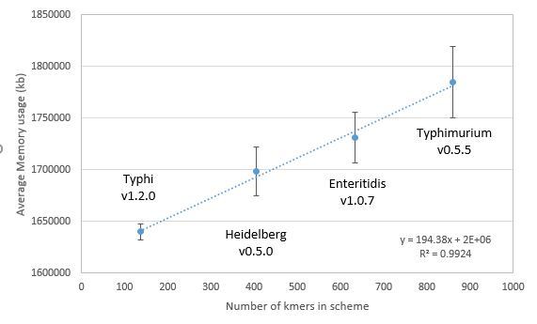

Figure S5.  Average BioHansel memory usage on a high performance computer cluster environment.  The datasets included 1000 assemblies of Typhi, SH, SE, and ST.  Each data point represents the average of at least 8 different experiments.